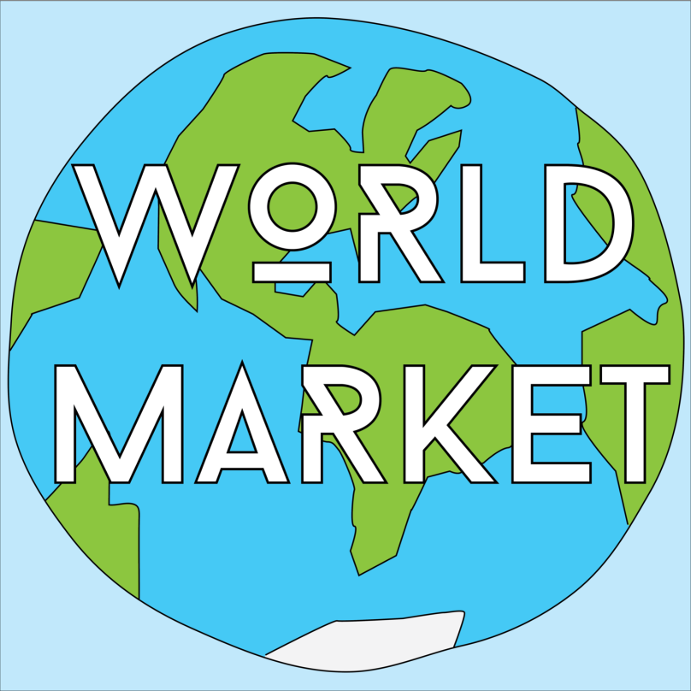
Westminster United Church presents
The Newcomer's World Market

Saturday December 1, 2018
10:00am to 2:00pm
Cameron Street Entrance
Come, and buy from around the World!
Over 15 Countries represented
Admission is a donation at the door to the
WUC Refugee Fund!

